**Compute the Purchase Cost**

The list of item details are given. Select the item and enter the quantity you want to purchase. Compute the total purchased cost and display in a div Dynamically.

**Problem Specification :**

* The file name should be **index.html**.
* Create an external script file named **script.js**.
* Include the script file into html page.
* When the user choose the item and entered the quantity display the total cost in another div dynamically.

Create a function named **Item** which represents a class with the following variables

* **itemName**
* **price**
* **availableQuantity**

Predefine the item details in an array  
Include the following functions/methods in script file

|  |  |
| --- | --- |
| **Function Name** | **Description** |
| getItemDetails() | In this function load the item details by calling createItem function and display it in the tablular form as shown in the screenshot when page is loaded |
| compute() | It will compute  the total cost for the selected items and quantity and display it. |
| createItem() | In this function create an array of items and return the array. |

Display the item details in a table with the following details **Select[checkbox], Itemname, Price, AvailableQuantity,Enter the quantity[textbox]** .   
All values will be displayed on loading the page.   
Compute the total cost of the purchase while entering the value of quantity if the select checkbox is selected.   
The total purchased cost of the items will be computed and displayed dynamically whenever we changing the selection of the items and quantity.   
  
**[Note :Strictly adhere to the specifications given in the screenshot. Use the same id names for all the corresponding fields specified.]**   
  
**Sample Screenshot 1:**   
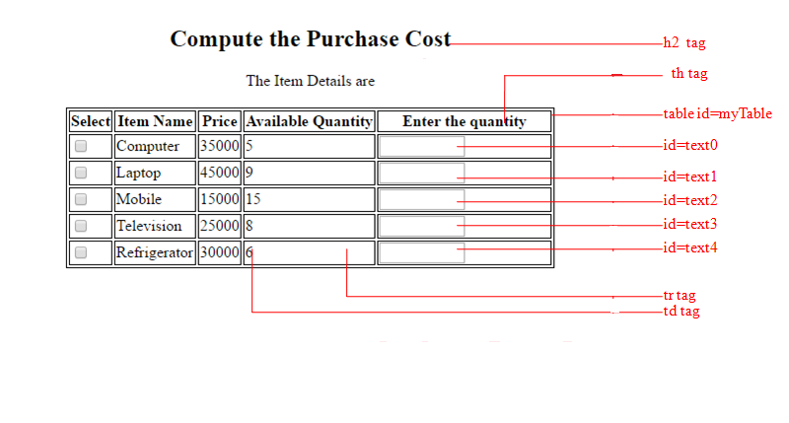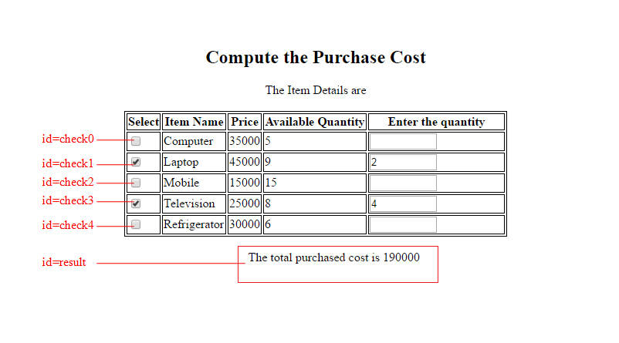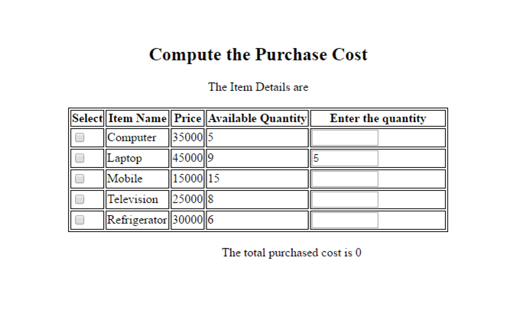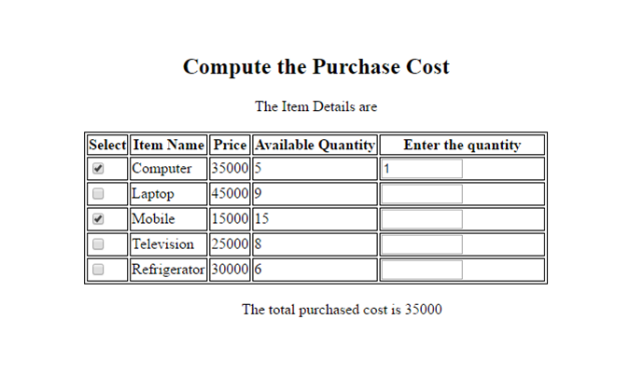

**Sample Screenshot 2:**  
  
**Sample** **Screenshot 3:**

**Sample** **Screenshot 4:**